- Write a program to simulate the working of stack using an array with the following: a) Push b) Pop c) Display The program should print appropriate messages for stack overflow, stack underflow
(27/9/25)

#include <stdio.h>
#include <stdlib.h>

#define MAX 5

int stack[MAX];
int top = -1;

void push(int value) {
if (top == MAX - 1) {
printf("Stack Overflow! Cannot push %d\n", value);
} else {
stack[++top] = value;
printf("%d pushed into stack\n", value);
}
}

void pop() {
if (top == -1) {
printf("Stack Underflow! Stack is empty\n");
} else {
printf("%d popped from stack\n", stack[top--]);
}
}

void display() {
if (top == -1) {
printf("Stack is empty\n");
} else {
printf("Stack elements are: ");
for (int i = top; i >= 0; i--) {
printf("%d ", stack[i]);
}
printf("\n");
}
}

int main() {
int choice, value;

while (1) {
printf("\n--- Stack Menu ---\n");
printf("1. Push\n");
printf("2. Pop\n");
printf("3. Display\n");
printf("4. Exit\n");
printf("Enter your choice: ");
scanf("%d", &choice);

switch (choice) {
case 1:
printf("Enter value to push: ");
scanf("%d", &value);
push(value);
break;

case 2:
pop();
break;

case 3:
display();
break;

case 4:
exit(0);

default:
printf("Invalid choice! Try again.\n");
}
}

return 0;
}

OUTPUT:
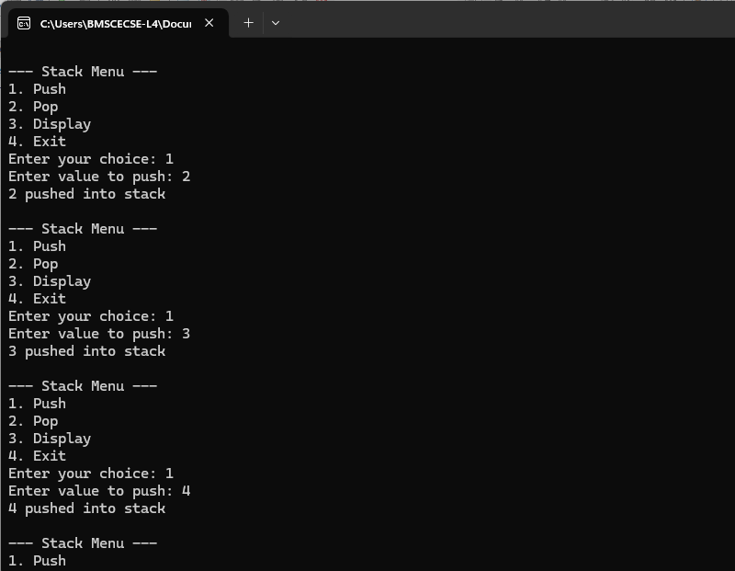
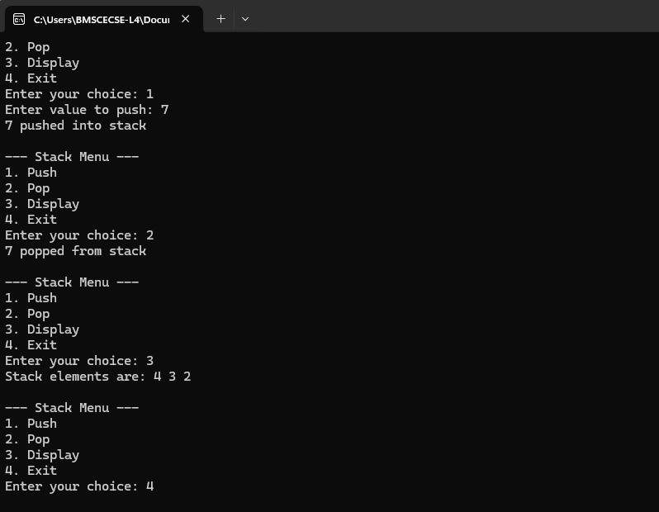
- WAP to convert a given valid parenthesized infix arithmetic expression to postfix expression. The expression consists of single character operands and the binary operators + (plus), - (minus), * (multiply) and / (divide)
(4/10/25)

#include <stdio.h>
#include <ctype.h> // for isalnum()
#define MAX 50

char stack[MAX];
int top = -1;

void push(char c) {
stack[++top] = c;
}

char pop() {
return stack[top--];
}

int precedence(char op) {
if (op == '+' || op == '-')
return 1;
if (op == '*' || op == '/')
return 2;
return 0;
}

int main() {
char infix[MAX], postfix[MAX];
int i, j = 0;
char ch;

printf("Enter a valid parenthesized infix expression: ");
scanf("%s", infix);

for (i = 0; infix[i] != '\0'; i++) {
ch = infix[i];

if (isalnum(ch)) {
postfix[j++] = ch;
}
else if (ch == '(') {
push(ch);
}
else if (ch == ')') {
while (top != -1 && stack[top] != '(') {
postfix[j++] = pop();
}
pop();
}
else {
while (top != -1 && precedence(stack[top]) >= precedence(ch)) {
postfix[j++] = pop();
}
push(ch);
}
}

while (top != -1) {
postfix[j++] = pop();
}

postfix[j] = '\0'; // null-terminate the string

printf("Postfix expression: %s\n", postfix);

return 0;
}

OUTPUT:
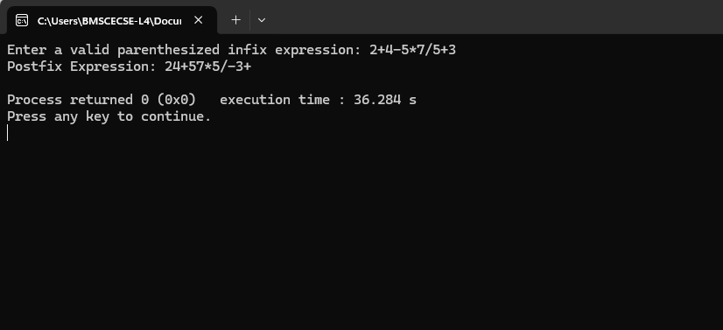
- a) WAP to simulate the working of a queue of integers using an array. Provide the following operations: Insert, Delete, Display The programshould print appropriate messagesfor queue empty and queue overflow conditions
(18/10/25)

#include <stdio.h>
#include <stdlib.h>
#define MAX 5

int f = -1, r = -1;
int queue[MAX];

void Insert(int ele) {
if (r == MAX - 1) {
printf("Queue Overflow!\n");
} else {
if (f == -1) f = 0;
queue[++r] = ele;

}
}

void pop() {
if (f == -1 || f > r) {
printf("Queue Underflow!\n");
} else {
int deleted = queue[f++];
printf(" %d is poped\n", deleted);
if (f > r) {

f = r = -1;
}
}
}

void display() {
if (f == -1) {
printf("Queue is empty!\n");
} else {

for (int i = f; i <= r; i++) {
printf("%d ", queue[i]);
}
printf("\n");
}
}

int main() {
int choice, value;
while (1) {

printf("1. Insert\n2. pop\n3. Display\n4. Exit\n");
printf("Enter your choice: ");
scanf("%d", &choice);

switch (choice) {
case 1:
printf("Enter value: ");
scanf("%d", &value);
Insert(value);
break;

case 2:
pop();
break;

case 3:
display();
break;

case 4:
printf("Thank you");
exit(0);

default:
printf("Invalid choice!\n");
}
}
return 0;
}

OUTPUT:
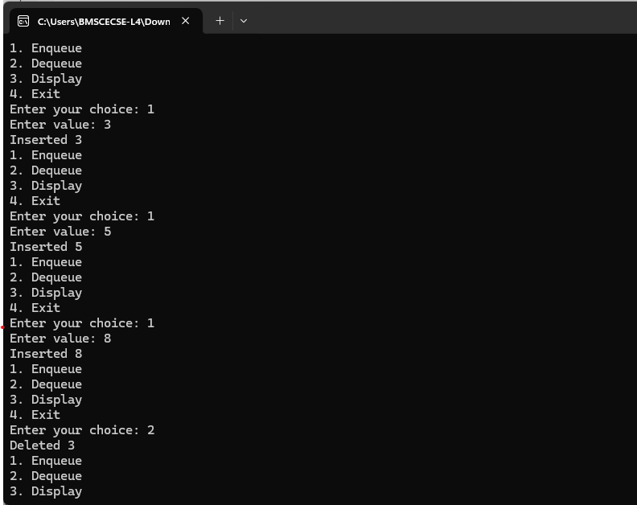
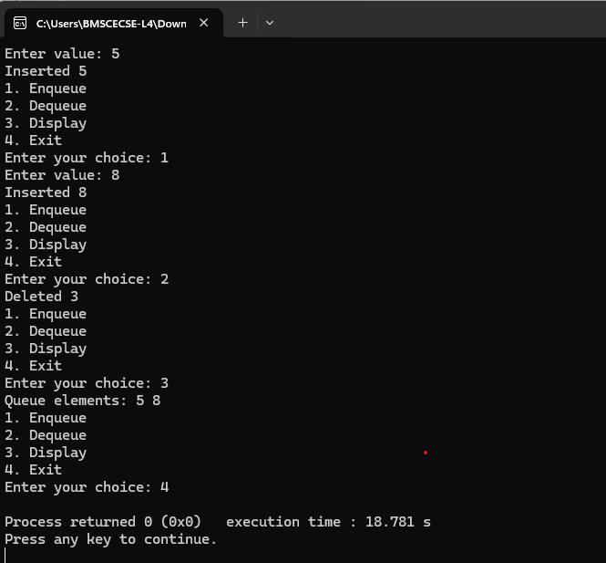
b ) WAP to simulate the working of a circular queue of integers using an array. Provide the following operations: Insert, Delete & Display The programshould print appropriate messagesfor queue empty and queue overflow conditions
(15/11/25)

#include <stdio.h>
#include <stdlib.h>
#define MAX 5

int queue[MAX];
int front = -1, rear = -1;

int isFull() {
return (front == (rear + 1) % MAX);
}

int isEmpty() {
return (front == -1);
}

void enqueue(int value) {
if (isFull()) {
printf("Queue Overflow! (Full)\n");
} else {
if (front == -1)
front = 0;
rear = (rear + 1) % MAX;
queue[rear] = value;
printf("Inserted %d\n", value);
}
}

void dequeue() {
if (isEmpty()) {
printf("Queue Underflow! (Empty)\n");
} else {
int deleted = queue[front];
if (front == rear) {

front = rear = -1;
} else {
front = (front + 1) % MAX;
}
printf("Deleted %d\n", deleted);
}
}

void display() {
if (isEmpty()) {
printf("Queue is empty!\n");
} else {
printf("Queue elements: ");
int i = front;
while (1) {
printf("%d ", queue[i]);
if (i == rear)
break;
i = (i + 1) % MAX;
}
printf("\n");
}
}

int main() {
int choice, value;

while (1) {

printf("1. Enqueue\n2. Dequeue\n3. Display\n4. Exit\n");
printf("Enter your choice: ");
scanf("%d", &choice);

switch (choice) {
case 1:
printf("Enter value: ");
scanf("%d", &value);
enqueue(value);
break;
case 2:
dequeue();
break;
case 3:
display();
break;
case 4:
exit(0);
default:
printf("Invalid choice!\n");
}
}
return 0;
}

OUTPUT:
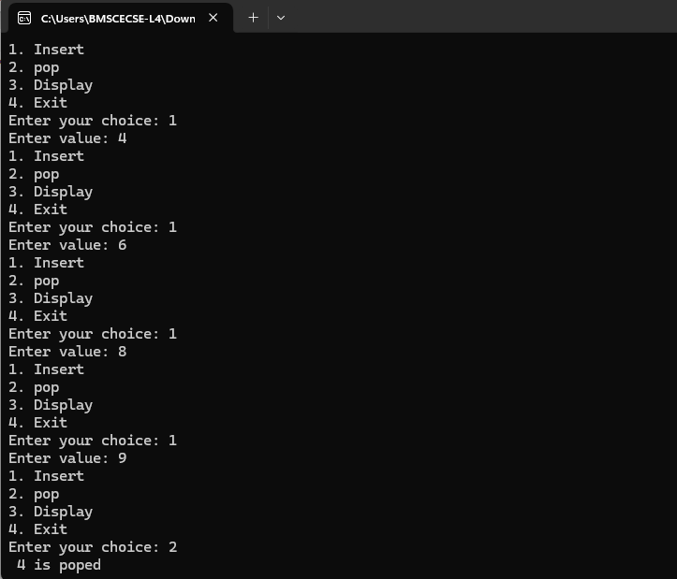
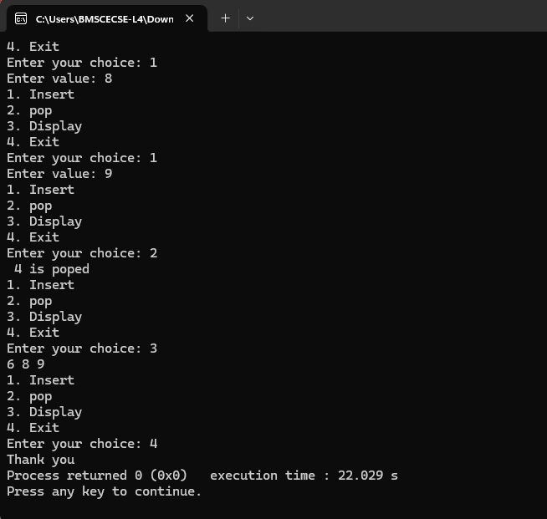
- WAP to Implement Singly Linked List with following operations a) Createalinkedlist. b) Insertion of a node at first position, at any position and at end of list. Display the contents of the linked list
- WAP to Implement Singly Linked List with following operations a) Create a linked list. b) Deletion of first element, specified element and last element in the list. c) Display the contents of the linked list.
(22/11/25)

#include <stdio.h>
#include <stdlib.h>

struct Node {
int data;
struct Node *next;
};

struct Node *head = NULL;

struct Node* createNode(int data) {
struct Node *newNode = (struct Node*) malloc(sizeof(struct Node));
newNode->data = data;
newNode->next = NULL;
return newNode;
}

void insertAtFront(int data) {
struct Node *newNode = createNode(data);
newNode->next = head;
head = newNode;
printf("%d inserted at front.\n", data);
}

void insertAtEnd(int data) {
struct Node *newNode = createNode(data);
if (head == NULL) {
head = newNode;
} else {
struct Node *temp = head;
while (temp->next != NULL)
temp = temp->next;
temp->next = newNode;
}
printf("%d inserted at end.\n", data);
}

void insertAtPosition(int data, int pos) {
struct Node *newNode = createNode(data);

if (pos == 1) {
newNode->next = head;
head = newNode;
printf("%d inserted at position %d.\n", data, pos);
return;
}

struct Node *temp = head;
for (int i = 1; temp != NULL && i < pos - 1; i++)
temp = temp->next;

if (temp == NULL) {
printf("Invalid position!\n");
free(newNode);
return;
}

newNode->next = temp->next;
temp->next = newNode;
printf("%d inserted at position %d.\n", data, pos);
}

void deleteFromFront() {
if (head == NULL) {
printf("List is empty!\n");
return;
}
struct Node *temp = head;
head = head->next;
printf("%d deleted from front.\n", temp->data);
free(temp);
}

void deleteFromEnd() {
if (head == NULL) {
printf("List is empty!\n");
return;
}
if (head->next == NULL) {
printf("%d deleted from end.\n", head->data);
free(head);
head = NULL;
return;
}

struct Node *temp = head;
while (temp->next->next != NULL)
temp = temp->next;

printf("%d deleted from end.\n", temp->next->data);
free(temp->next);
temp->next = NULL;
}

void deleteFromPosition(int pos) {
if (head == NULL) {
printf("List is empty!\n");
return;
}

struct Node *temp = head;

if (pos == 1) {
head = head->next;
printf("%d deleted from position %d.\n", temp->data, pos);
free(temp);
return;
}

for (int i = 1; temp != NULL && i < pos - 1; i++)
temp = temp->next;

if (temp == NULL || temp->next == NULL) {
printf("Invalid position!\n");
return;
}

struct Node *delNode = temp->next;
temp->next = delNode->next;
printf("%d deleted from position %d.\n", delNode->data, pos);
free(delNode);
}

void displayList() {
if (head == NULL) {
printf("List is empty!\n");
return;
}
struct Node *temp = head;
printf("Linked List: ");
while (temp != NULL) {
printf("%d -> ", temp->data);
temp = temp->next;
}
printf("NULL\n");
}

int main() {
int choice, data, pos;

while (1) {
printf("\n--- Singly Linked List Operations ---\n");
printf("1. Insert at Front\n");
printf("2. Insert at End\n");
printf("3. Insert at Position\n");
printf("4. Delete from Front\n");
printf("5. Delete from End\n");
printf("6. Delete from Position\n");
printf("7. Display List\n");
printf("8. Exit\n");
printf("Enter your choice: ");
scanf("%d", &choice);

switch (choice) {

case 1:
printf("Enter data: ");
scanf("%d", &data);
insertAtFront(data);
break;
case 2:
printf("Enter data: ");
scanf("%d", &data);
insertAtEnd(data);
break;
case 3:
printf("Enter data and position: ");
scanf("%d %d", &data, &pos);
insertAtPosition(data, pos);
break;
case 4:
deleteFromFront();
break;
case 5:
deleteFromEnd();
break;
case 6:
printf("Enter position to delete: ");
scanf("%d", &pos);
deleteFromPosition(pos);
break;
case 7:
displayList();
break;
case 8:
printf("Exiting...\n");
exit(0);
default:
printf("Invalid choice! Try again.\n");
}
}
return 0;
}

OUTPUT:
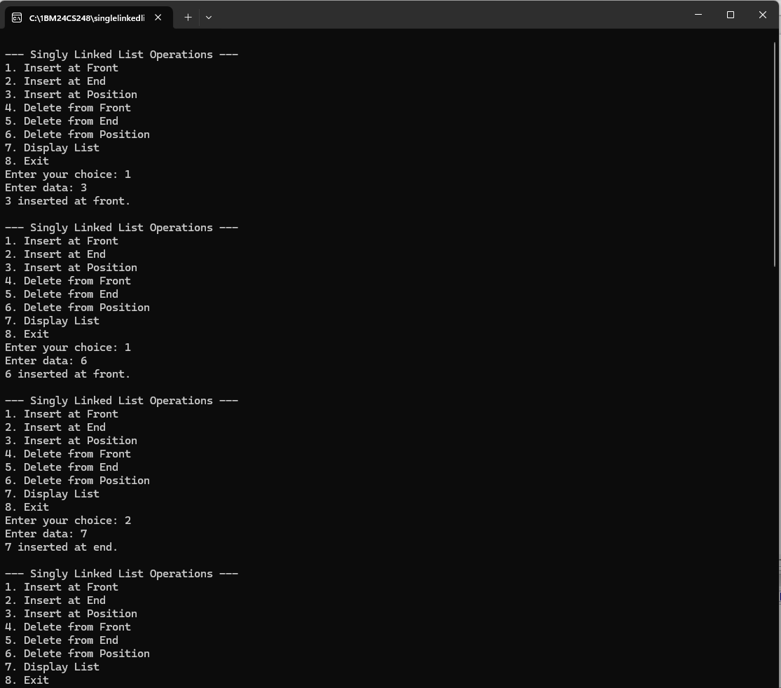
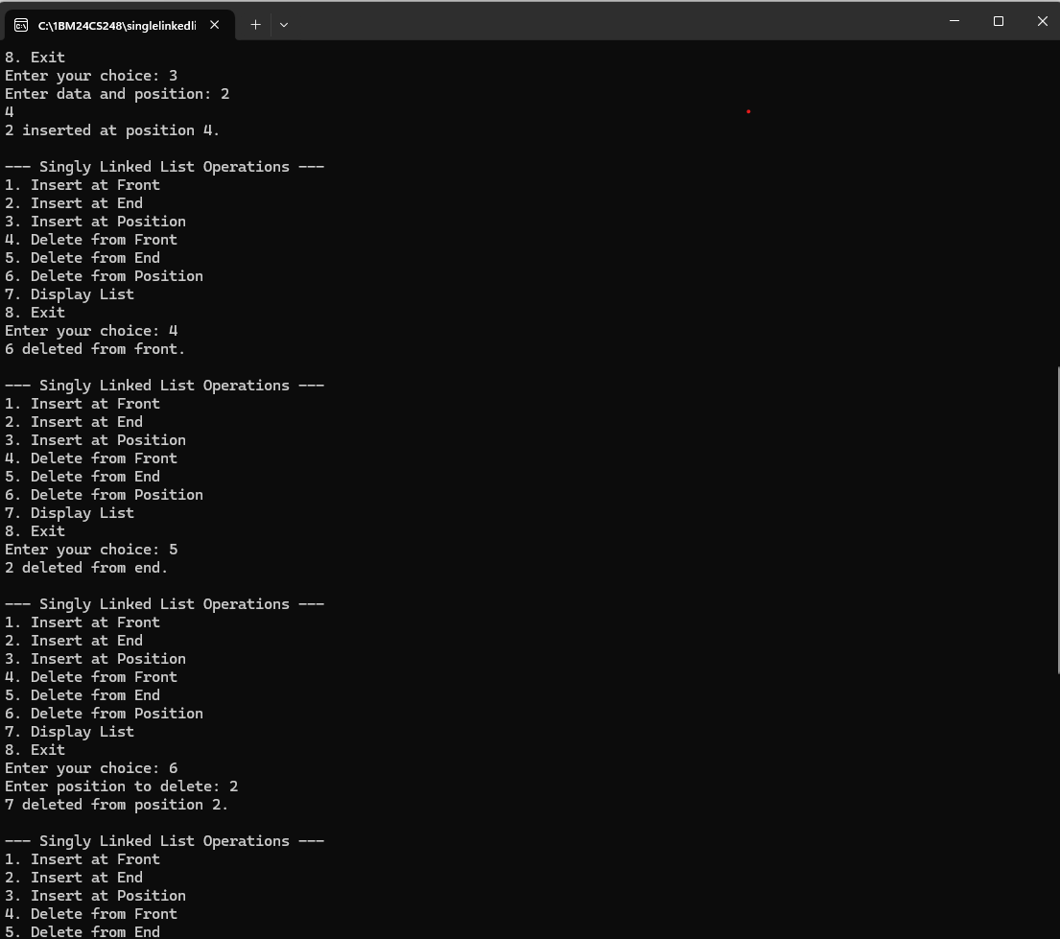
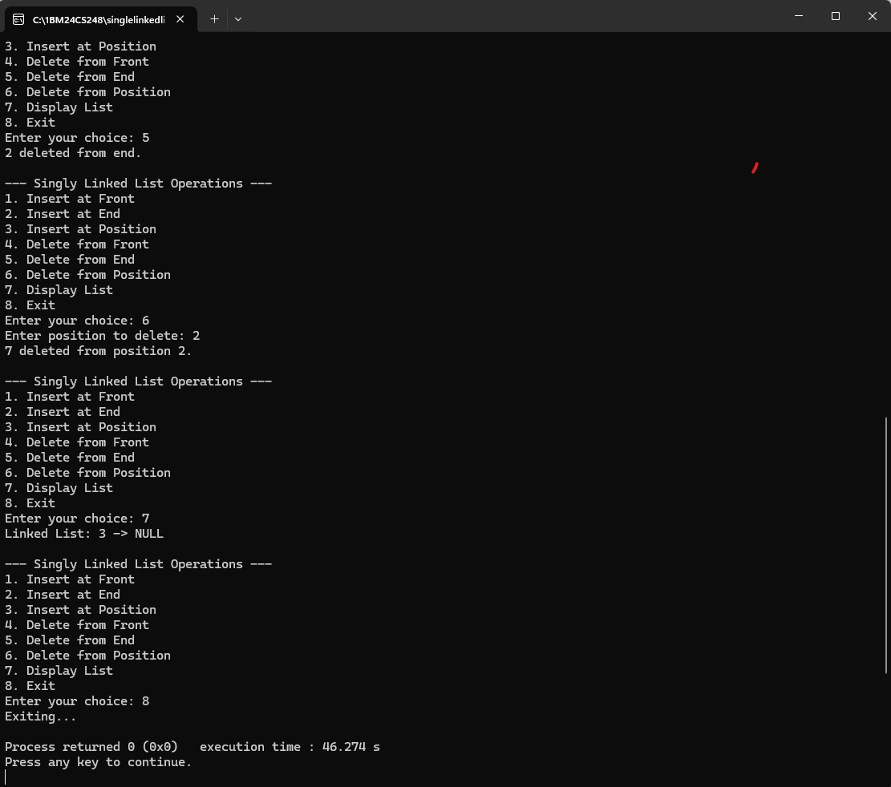

- a) WAP to Implement Single Link List with following operations: Sort the linked list, Reverse the linked list, Concatenation of two linked lists.
(29/11/25)

#include <stdio.h>
#include <stdlib.h>

struct Node {
int data;
struct Node *next;
};

struct Node *head1 = NULL, *head2 = NULL;

void insertEnd(struct Node **head, int value) {
struct Node *newNode = (struct Node*)malloc(sizeof(struct Node));
newNode->data = value;
newNode->next = NULL;

if (*head == NULL) {
*head = newNode;
return;
}
struct Node *temp = *head;
while (temp->next != NULL)
temp = temp->next;
temp->next = newNode;
}

void display(struct Node *head) {
if (head == NULL) {
printf("List Empty!\n");
return;
}
while (head != NULL) {
printf("%d -> ", head->data);
head = head->next;
}
printf("NULL\n");
}

void sortList(struct Node *head) {
struct Node *i, *j;
int temp;
if (head == NULL) return;

for (i = head; i->next != NULL; i = i->next) {
for (j = i->next; j != NULL; j = j->next) {
if (i->data > j->data) {
temp = i->data;
i->data = j->data;
j->data = temp;
}
}
}
}

struct Node* reverseList(struct Node *head) {
struct Node *prev = NULL, *current = head, *next = NULL;
while (current != NULL) {
next = current->next;
current->next = prev;
prev = current;
current = next;
}
return prev;
}

void concatenate() {
if (head1 == NULL) {
head1 = head2;
return;
}
struct Node *temp = head1;
while (temp->next != NULL)
temp = temp->next;
temp->next = head2;
}

int main() {
int choice, val;

while (1) {
printf("\n--- Linked List Menu ---\n");
printf("1. Insert in List1\n2. Insert in List2\n3. Display List1\n4. Display List2\n");
printf("5. Sort List1\n6. Reverse List1\n7. Concatenate Lists\n8. Exit\n");
printf("Enter choice: ");
scanf("%d", &choice);

switch (choice) {
case 1:
printf("Enter value: ");
scanf("%d", &val);
insertEnd(&head1, val);
break;
case 2:
printf("Enter value: ");
scanf("%d", &val);
insertEnd(&head2, val);
break;
case 3:
display(head1);
break;
case 4:
display(head2);
break;
case 5:
sortList(head1);
printf("List Sorted!\n");
break;
case 6:
head1 = reverseList(head1);
printf("List Reversed!\n");
break;
case 7:
concatenate();
printf("Concatenated! Updated List1: ");
display(head1);
break;
case 8:
exit(0);
default:
printf("Invalid Choice!\n");
}
}
}

OUTPUT:
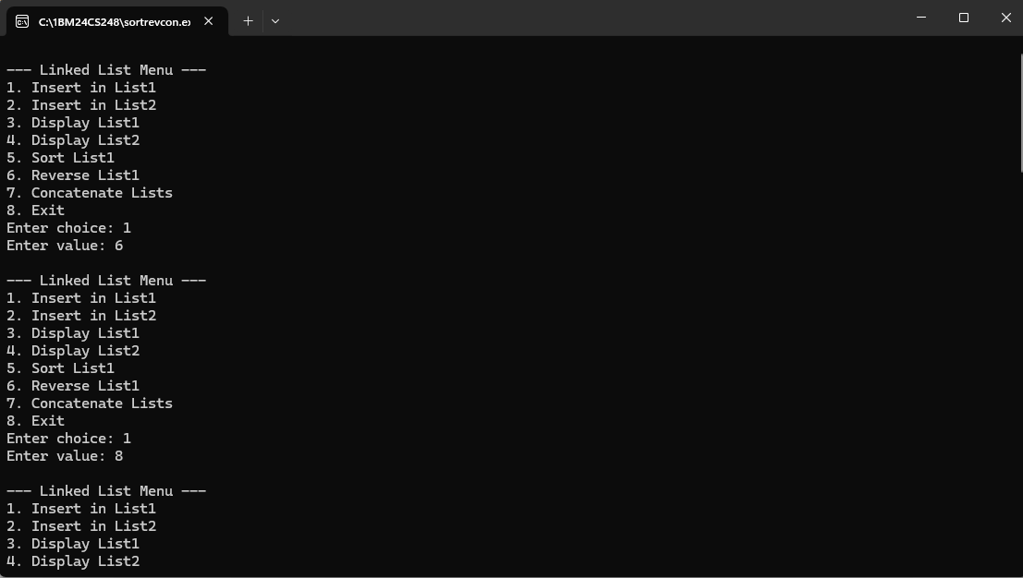
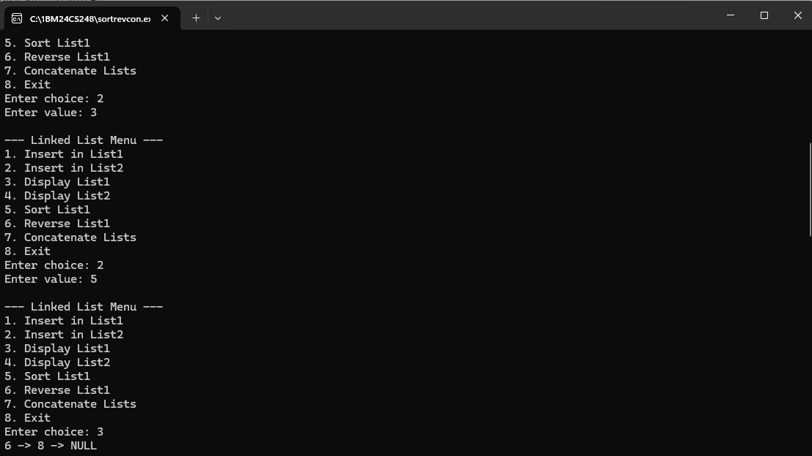
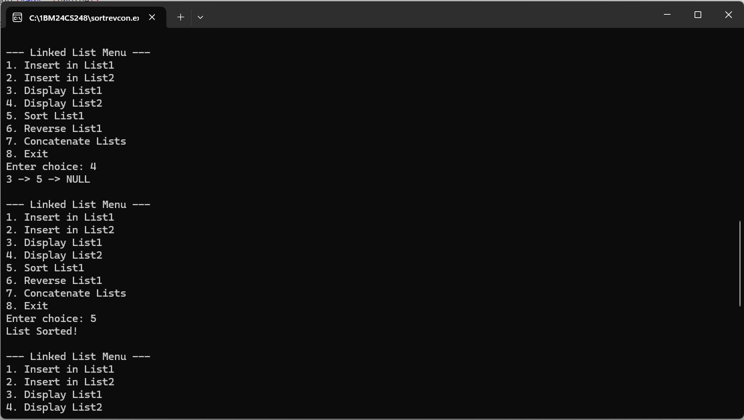
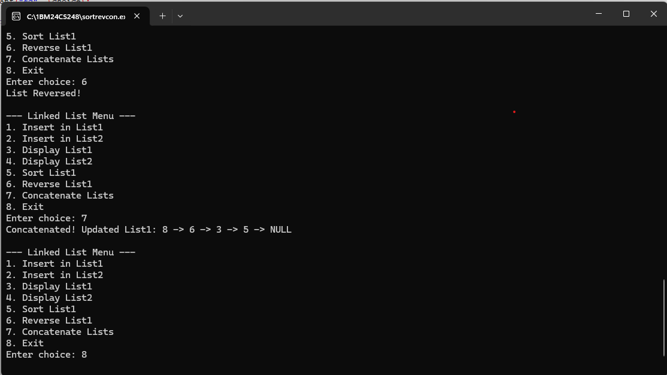

b) WAP to Implement Single Link List to simulate Stack & Queue Operations.
(29/11/25)

#include <stdio.h>
#include <stdlib.h>

struct Node {
int data;
struct Node *next;
};

struct Node *top = NULL;
struct Node *front = NULL, *rear = NULL;

void push(int val) {
struct Node *newNode = (struct Node*)malloc(sizeof(struct Node));
newNode->data = val;
newNode->next = top;
top = newNode;
printf("Pushed %d\n", val);
}

void pop() {
if (top == NULL) {
printf("Stack Underflow!\n");
return;
}
struct Node *temp = top;
printf("Popped %d\n", top->data);
top = top->next;
free(temp);
}

void displayStack() {
struct Node *temp = top;
printf("Stack: ");
while (temp != NULL) {
printf("%d -> ", temp->data);
temp = temp->next;
}
printf("NULL\n");
}

void enqueue(int val) {
struct Node *newNode = (struct Node*)malloc(sizeof(struct Node));
newNode->data = val;
newNode->next = NULL;

if (rear == NULL) {
front = rear = newNode;
} else {
rear->next = newNode;
rear = newNode;
}
printf("Enqueued %d\n", val);
}

void dequeue() {
if (front == NULL) {
printf("Queue Underflow!\n");
return;
}
struct Node *temp = front;
printf("Dequeued %d\n", front->data);
front = front->next;
if (front == NULL) rear = NULL;
free(temp);
}

void displayQueue() {
struct Node *temp = front;
printf("Queue: ");
while (temp != NULL) {
printf("%d -> ", temp->data);
temp = temp->next;
}
printf("NULL\n");
}

int main() {
int choice, val;

while (1) {
printf("\n--- Menu ---\n");
printf("1. Push\n2. Pop\n3. Display Stack\n");
printf("4. Enqueue\n5. Dequeue\n6. Display Queue\n7. Exit\n");
printf("Enter choice: ");
scanf("%d", &choice);

switch (choice) {
case 1:
printf("Enter value: ");
scanf("%d", &val);
push(val); break;
case 2:
pop(); break;
case 3:
displayStack(); break;
case 4:
printf("Enter value: ");
scanf("%d", &val);
enqueue(val); break;
case 5:
dequeue(); break;
case 6:
displayQueue(); break;
case 7:
exit(0);
default:
printf("Invalid Choice!\n");
}
}
}

OUTPUT:

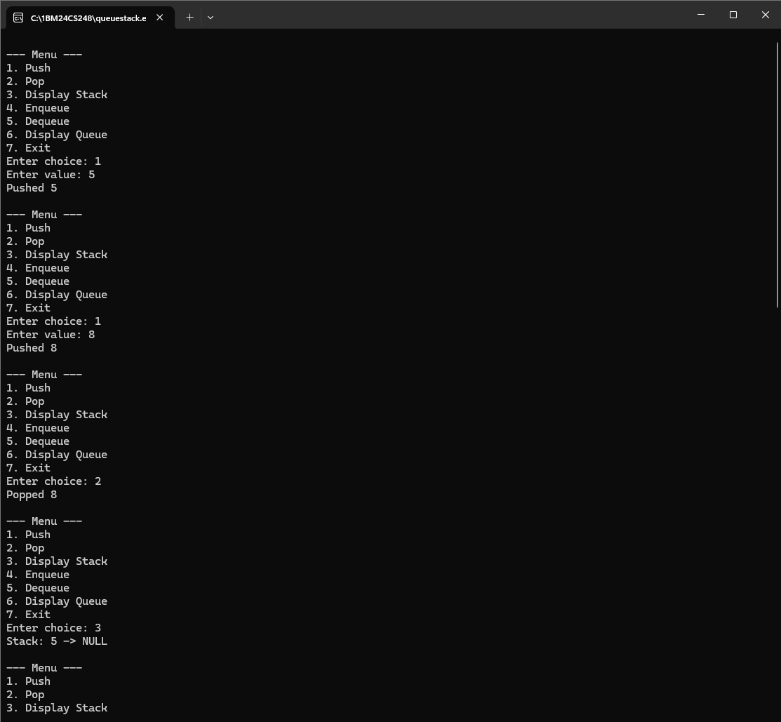
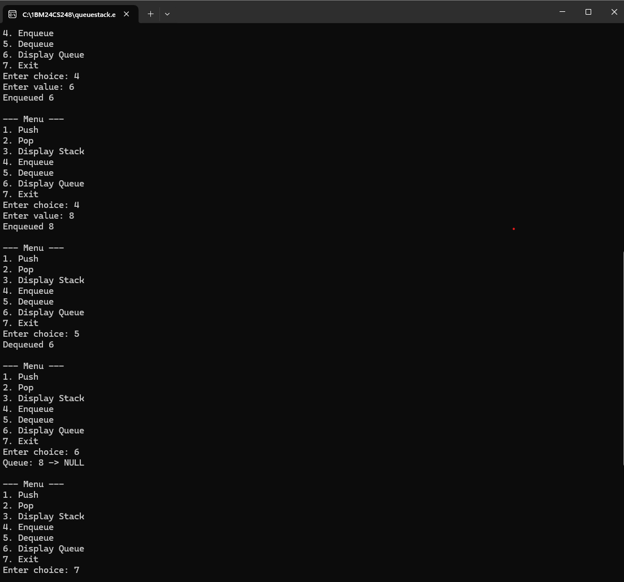
7.WAP to Implement doubly link list with primitive operations a) Create a doubly linked list. b) Insert a new node to the left of the node. c) Delete the node based on a specific value d) Display the contents of the list
(13/12/25)
#include <stdio.h>
#include <stdlib.h>

struct node {
int data;
struct node *prev;
struct node *next;
};

struct node *head = NULL;

void create(int n) {
int i, val;
struct node *newnode, *temp;

for (i = 0; i < n; i++) {
newnode = (struct node *)malloc(sizeof(struct node));
printf("Enter data: ");
scanf("%d", &val);

newnode->data = val;
newnode->prev = NULL;
newnode->next = NULL;

if (head == NULL) {
head = newnode;
temp = head;
} else {
temp->next = newnode;
newnode->prev = temp;
temp = newnode;
}
}
}

void insert_left(int key, int val) {
struct node *temp = head, *newnode;

while (temp != NULL && temp->data != key)
temp = temp->next;

if (temp == NULL) {
printf("Value %d not found\n", key);
return;
}

newnode = (struct node *)malloc(sizeof(struct node));
newnode->data = val;

newnode->next = temp;
newnode->prev = temp->prev;

if (temp->prev != NULL)
temp->prev->next = newnode;
else
head = newnode;

temp->prev = newnode;
}

void delete_value(int key) {
struct node *temp = head;

while (temp != NULL && temp->data != key)
temp = temp->next;

if (temp == NULL) {
printf("Value %d not found\n", key);
return;
}

if (temp->prev != NULL)
temp->prev->next = temp->next;
else
head = temp->next;

if (temp->next != NULL)
temp->next->prev = temp->prev;

free(temp);
}

void display() {
struct node *temp = head;

if (head == NULL) {
printf("List is empty\n");
return;
}

printf("Doubly Linked List: ");
while (temp != NULL) {
printf("%d <-> ", temp->data);
temp = temp->next;
}
printf("NULL\n");
}

int main() {
int choice, n, key, val;

while (1) {
printf("\n1. Create List");
printf("\n2. Insert to Left of a Node");
printf("\n3. Delete a Node by Value");
printf("\n4. Display List");
printf("\n5. Exit");
printf("\nEnter your choice: ");
scanf("%d", &choice);

switch (choice) {
case 1:
printf("Enter number of nodes: ");
scanf("%d", &n);
create(n);
break;

case 2:
printf("Enter value of existing node: ");
scanf("%d", &key);
printf("Enter new value to insert: ");
scanf("%d", &val);
insert_left(key, val);
break;

case 3:
printf("Enter value to delete: ");
scanf("%d", &key);
delete_value(key);
break;

case 4:
display();
break;

case 5:
exit(0);

default:
printf("Invalid choice\n");
}
}
return 0;
}

OUTPUT: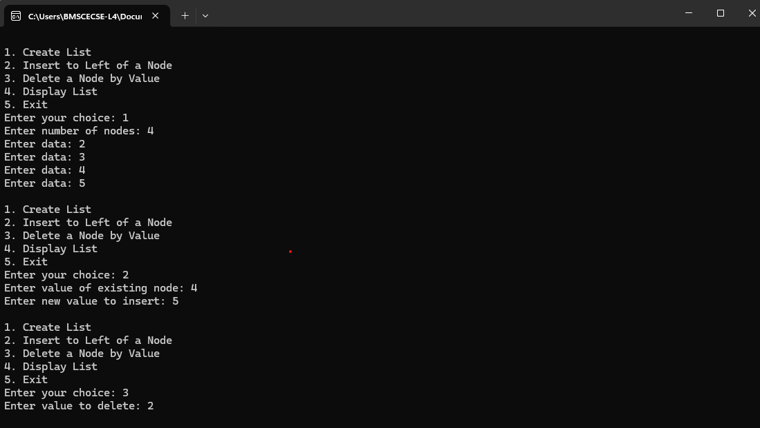
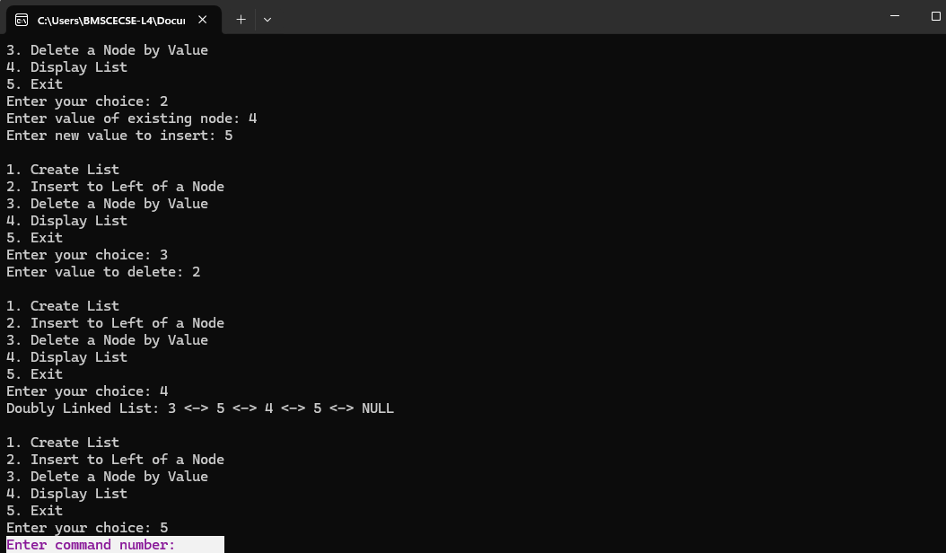

8. Write a program a) ToconstructabinarySearchtree.
b) To traverse the tree using all the methods i.e., in-order, preorder
and post order c) To display the elements in the tree
(13/12/25)

#include <stdio.h>
#include <stdlib.h>

/* Structure definition */
struct Node {
int data;
struct Node *left, *right;
};

/* Create a new node */
struct Node* createNode(int value) {
struct Node *newNode = (struct Node*)malloc(sizeof(struct Node));
newNode->data = value;
newNode->left = newNode->right = NULL;
return newNode;
}

/* a) Insert into BST */
struct Node* insert(struct Node *root, int value) {
if (root == NULL)
return createNode(value);

if (value < root->data)
root->left = insert(root->left, value);
else if (value > root->data)
root->right = insert(root->right, value);

return root;
}

/* b) Traversals */

/* Inorder Traversal */
void inorder(struct Node *root) {
if (root == NULL) return;
inorder(root->left);
printf("%d ", root->data);
inorder(root->right);
}

/* Preorder Traversal */
void preorder(struct Node *root) {
if (root == NULL) return;
printf("%d ", root->data);
preorder(root->left);
preorder(root->right);
}

/* Postorder Traversal */
void postorder(struct Node *root) {
if (root == NULL) return;
postorder(root->left);
postorder(root->right);
printf("%d ", root->data);
}

/* c) Display the elements in the tree */
void display(struct Node *root) {
if (root == NULL) {
printf("BST is empty\n");
return;
}
printf("BST Elements (Inorder): ");
inorder(root);
printf("\n");
}

int main() {
struct Node *root = NULL;
int choice, value;

while (1) {
printf("\n--- Binary Search Tree Menu ---\n");
printf("1. Insert into BST\n");
printf("2. Inorder Traversal\n");
printf("3. Preorder Traversal\n");
printf("4. Postorder Traversal\n");
printf("5. Display BST\n");
printf("6. Exit\n");
printf("Enter choice: ");
scanf("%d", &choice);

switch (choice) {
case 1:
printf("Enter value to insert: ");
scanf("%d", &value);
root = insert(root, value);
break;

case 2:
printf("Inorder Traversal: ");
inorder(root);
printf("\n");
break;

case 3:
printf("Preorder Traversal: ");
preorder(root);
printf("\n");
break;

case 4:
printf("Postorder Traversal: ");
postorder(root);
printf("\n");
break;

case 5:
display(root);
break;

case 6:
exit(0);

default:
printf("Invalid choice! Try again.\n");
}
}
return 0;
}

OUTPUT:

